CHAPTER I

# Introduction to Open Data

**What is Open Data?**

The world creates and stores more data every two days than it did since the beginning of time up until 2003.[1] Being able to access all this data freely has grown into a salient policy issue for governments especially and developing countries are facing unique challenges of all this new data with regards to its citizens - how much data should they share with their citizens and how? Who has access to it? Non-profits such as the Open Development Initiative (ODI) are seeking to leverage this new wealth of information to build up an open data and information network that the public can freely access.

**Open data is data that is free to use, re-use and distribute.** It has grown in popularity along with open-source software in which programmers can collaborate, share, design and use code already available to the general public. The support and popularity of open data rests on the assumptions that open data makes people and organizations more knowledgeable, that people have the freedom to access this information, and that it is free to access.

Many *governments* are signing on to Open Government Partnership as a way of disclosing their data to their citizens free of charge or licensing obligations. Below is an action plan cycle map of governments around the world.[2] Open data promotes transparency and encourages citizens to hold their governments accountable.

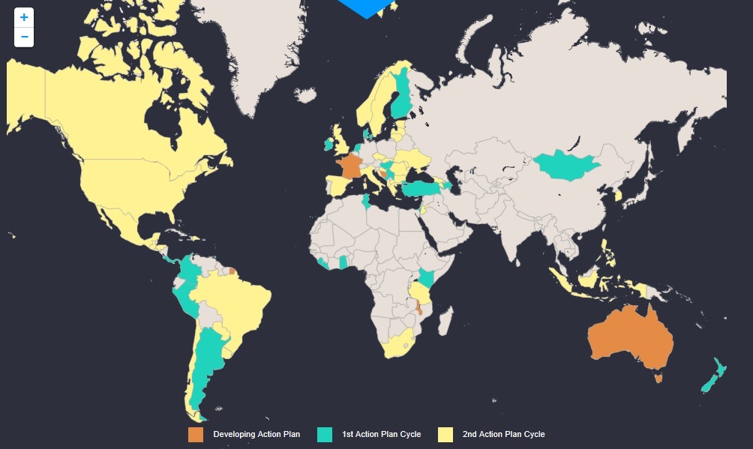

*Businesses* and *nonprofits* are using open data to disclose information about their organizations, increase transparency, and collaborate with other organizations through sharing their data.

*Research centers* and *academic institutions* publish their data so that the general public can access this open data in a way that strives to be accurate, timely, and accessible.

1. According to Google’s CEO Eric Schmidt
2. Open Government Partnership, <http://www.opengovpartnership.org/>